Screenshots from Experiment 7

* We include here screenshots for all pages of Experiment 7 as an example of what our one-shot experiments looked like. Experiments 4-6 are very similar, but with some questions left out (e.g., Experiment 4 & 5 only include the Prisoner’s Dilemma, and Experiment 6 only includes the Prisoner’s Dilemma and Stag-Hunt). The order of games in Experiment 6 is the same, but with Chicken left out (i.e, Stag-Hunt, then Prisoner’s Dilemma)
* These screenshots are, chosen randomly, for *Category 2*; the other categories are the same but with minor verbal changes (*Category 1* does not include the word ‘lose’ because all outcomes are positive and *Category 5* does not include the word ‘gain’ because all outcomes are negative).

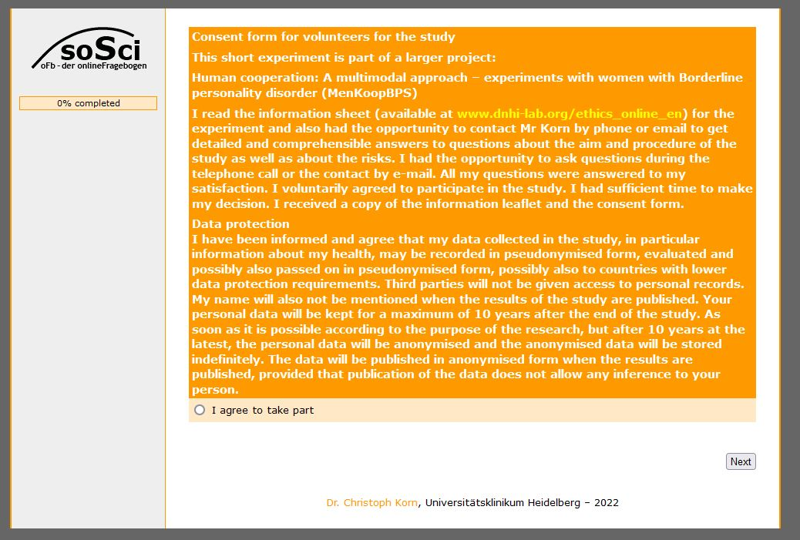

Figure - Page 1: Consent

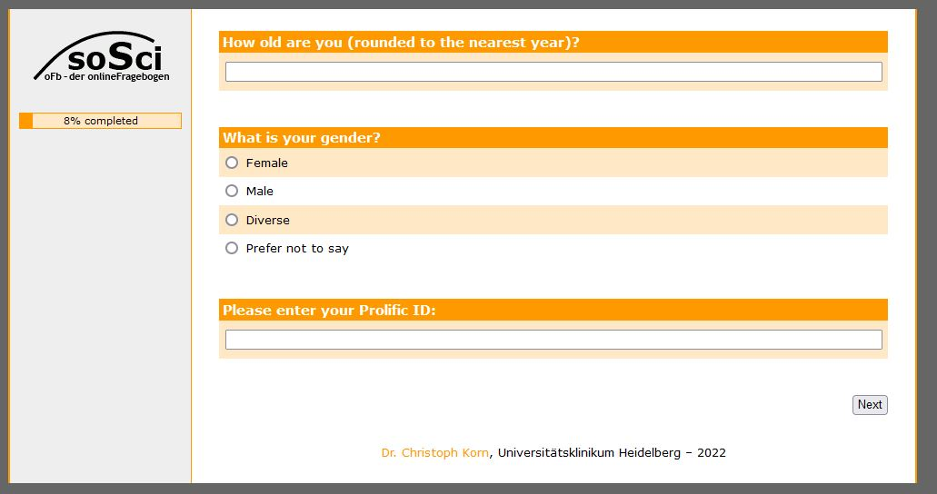

Figure - Page 2: Demographics and Prolific ID

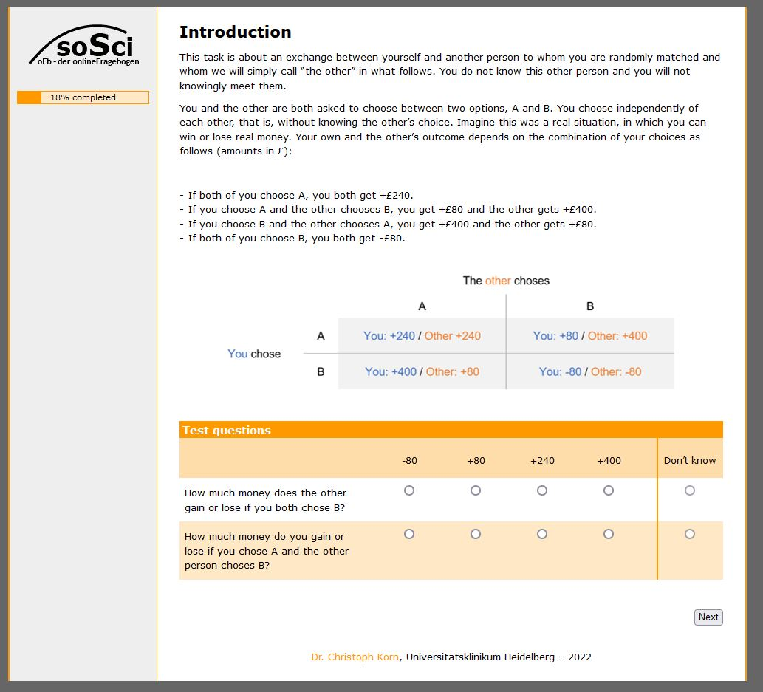

Figure - Page 3: Task instructions and test questions (with Chicken as example)

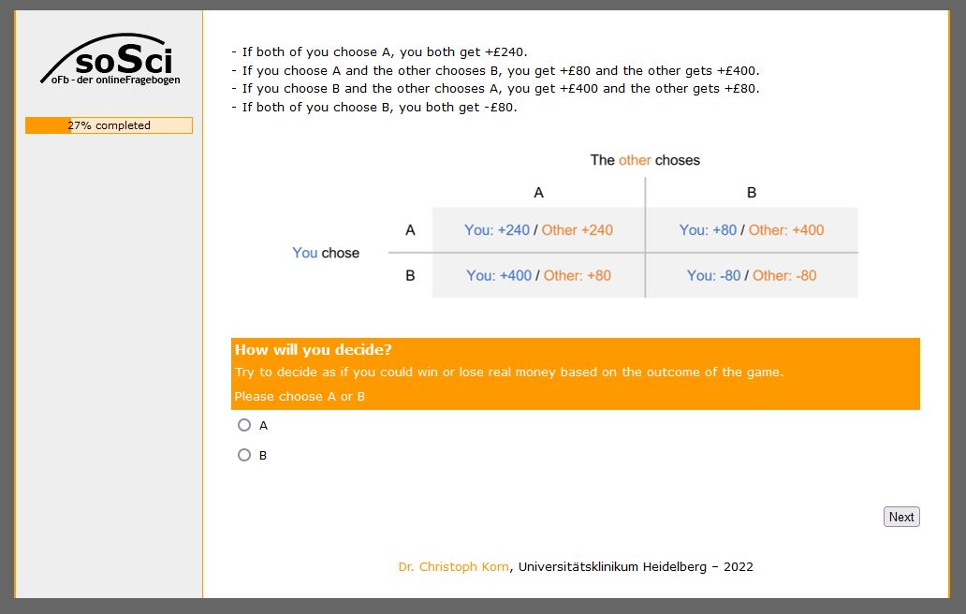

Figure - Page 4: Actual decision (for Chicken)

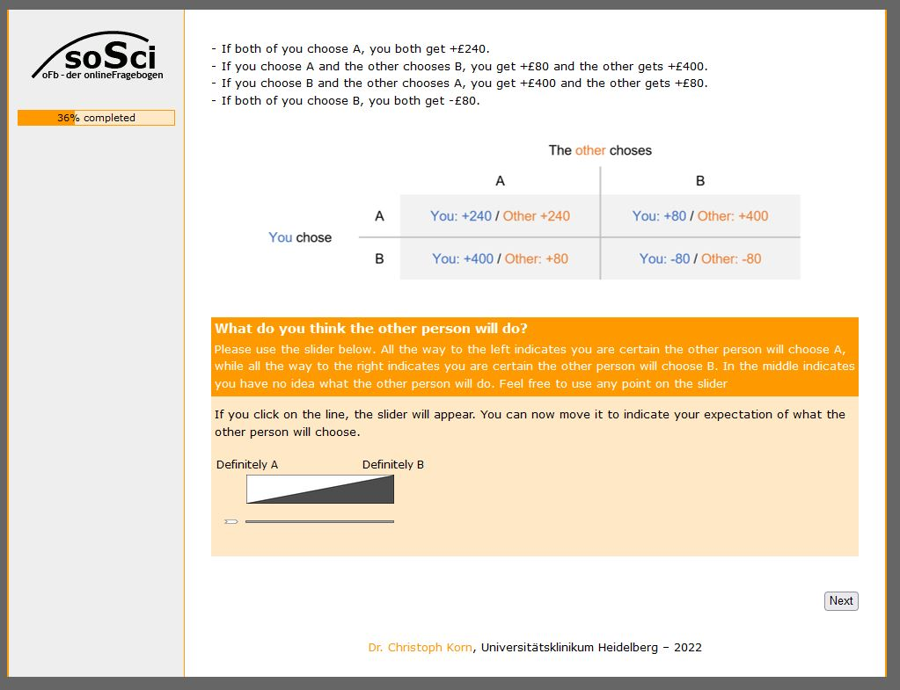

Figure - Page 5: Expectation of what the other will do, from 0% (Definitely A) to 100% (Definitely B), for Chicken

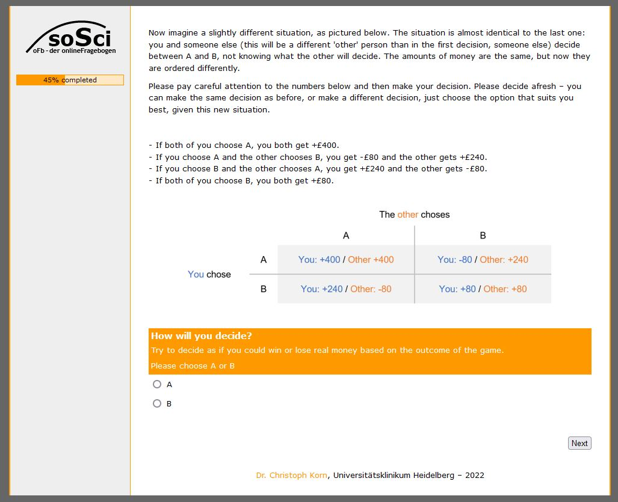

Figure - Page 6: Task instructions and actual decision for Stag-Hunt

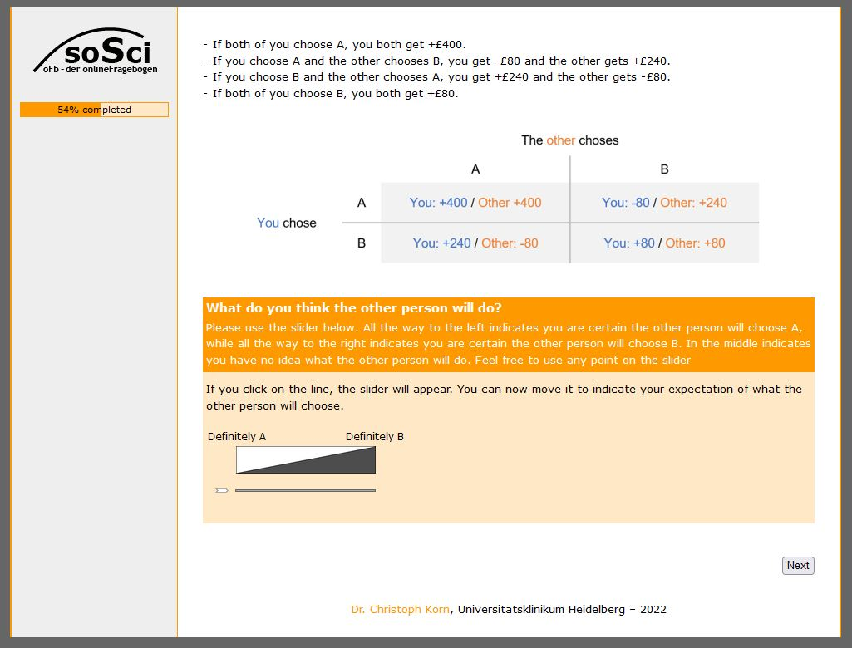

Figure - Page 7: Expectation of what other will do for Stag-Hunt

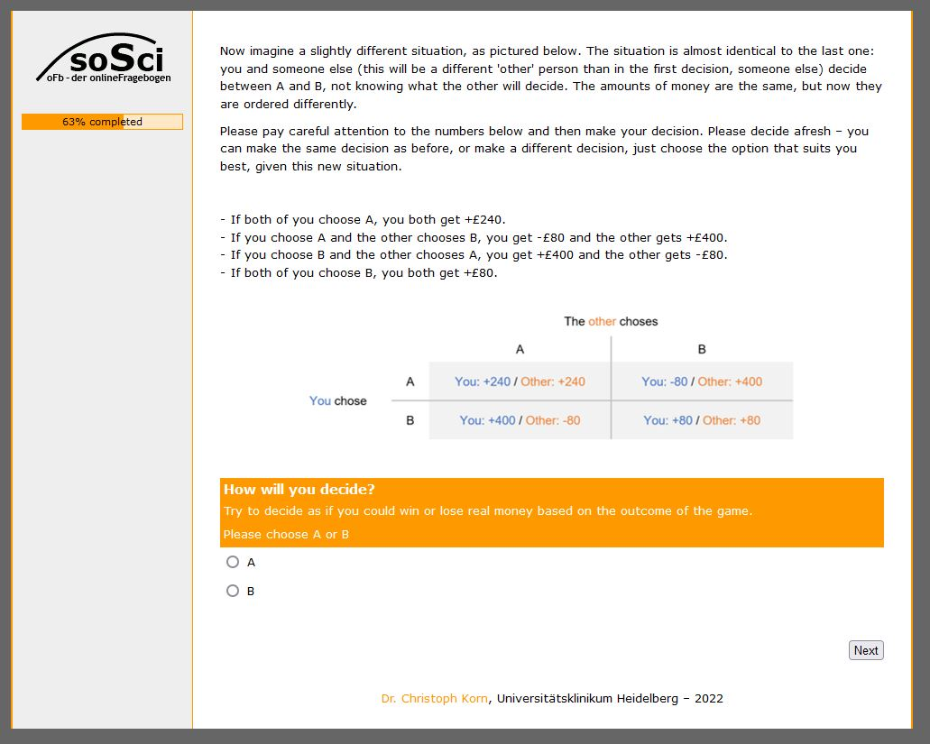

Figure - Page 8: Task instructions and actual decision for the Prisoner's Dilemma

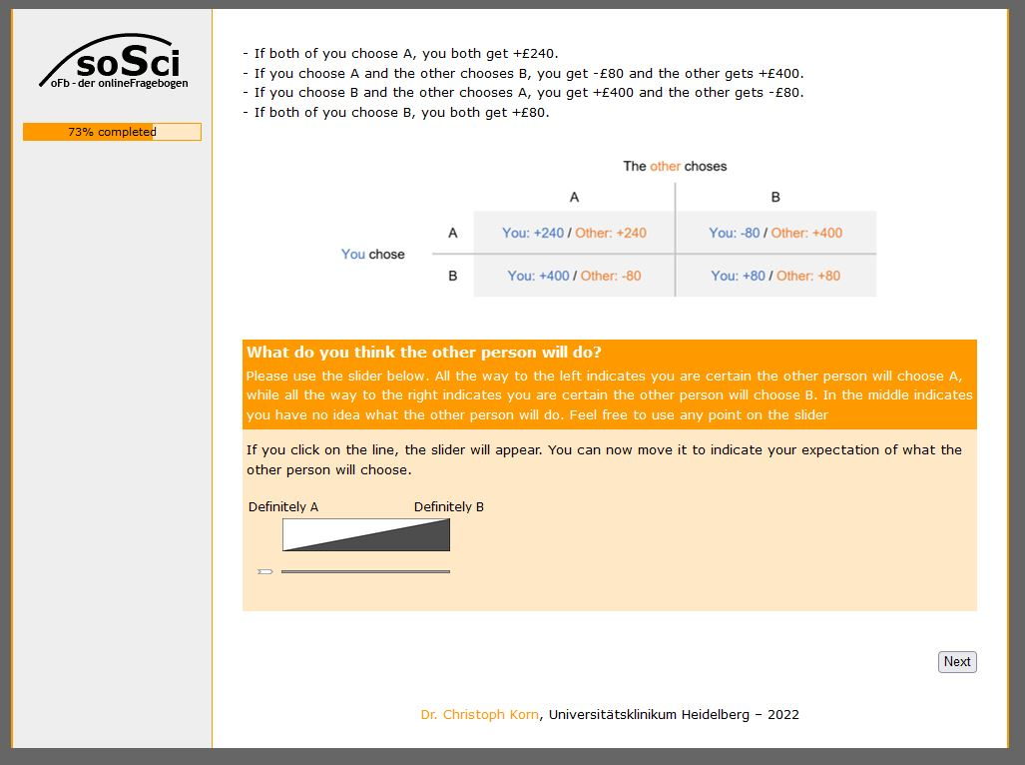

Figure - Page 9: Expectation of what other will do for the Prisoner's Dilemma

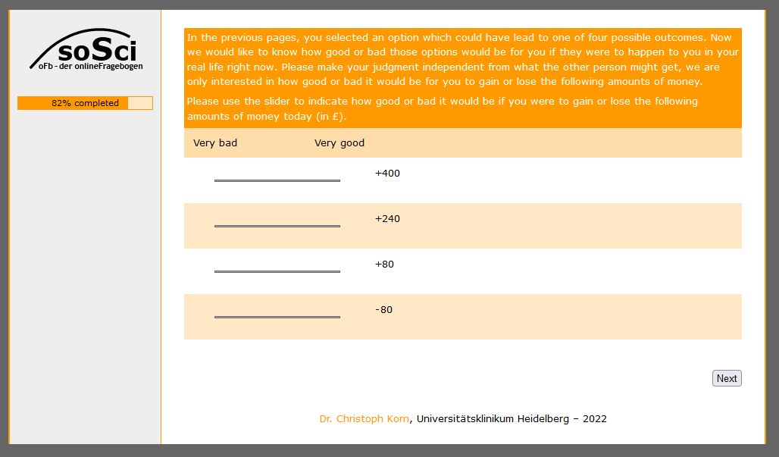

Figure - Page 10: Explicit utility ratings for the 4 possible outcomes for oneself, but independent of any social interaction

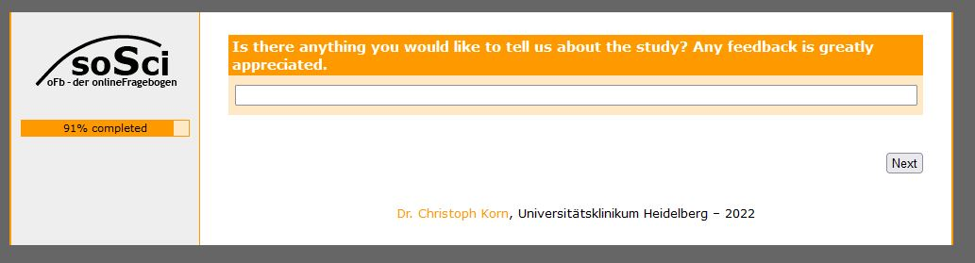

Figure - Page 11: Optional message to the Experimenters

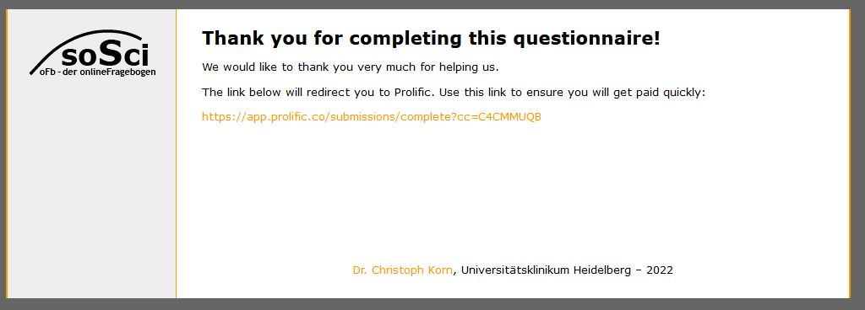

Figure - Page 12: Link back to Prolific and end of the study